|  |  |
| --- | --- |
|  | User Manual |
|  |  |
|  | Group 4  By Amandeep Tukhar, Tom Bestwick, Sami Idreesi, Adam Mazur, Saqab Mohammad, Vlad Septelici  4/23/20 |

Contents

App Boot Instructions 2

Login Instructions 2

Forgotten Password 4

Registration 5

Virtual Fridge 7

Adding Items 8

View Shopping List 9

Adding Shopping List Items 9

Removing Shopping List Items 10

Viewing Saved Recipes 11

Adding New Recipes 11

Viewing Profile Information 13

Settings Page 14

Change Username 14

Change Password 15

Change Profile Picture 16

# App Boot Instructions

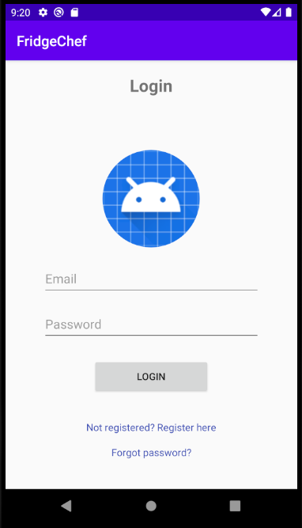

At first the user is presented with this screen on app start up.

# Login Instructions

**PRE-REQUISITES:**

* The user must have used the app before and made an account through the register page to be able to login through this screen.

1. The user must press the text-field with the ‘email’ placeholder and enter in an email address in the standard format of [xxx@xxx.xxx](mailto:xxx@xxx.xxx)

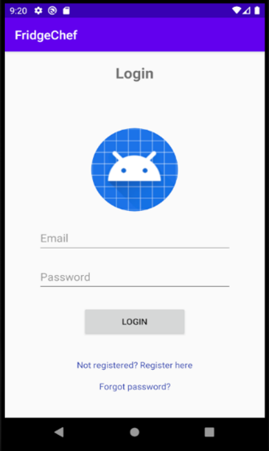

1. Next, the user must press the text-field with the ‘password’ placeholder and enter a secure memorable password.

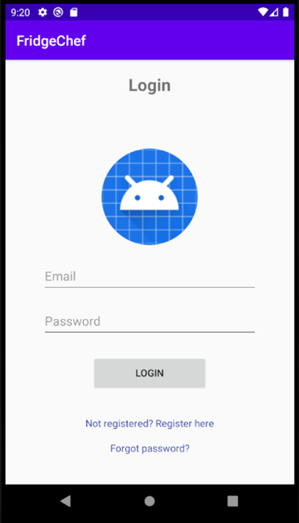

1. Finally, the user must press the ‘login’ button to get onto their account on the app and should be displayed with the main recipes page on login.



# Forgotten Password

**PRE-REQUISITES:**

* The user must have used the app before and made an account through the register page to be able to receive a new password

1. On the initial launch page, the user must press the ‘Forgot password?’ button



1. The user must press on the empty ‘whitespace’ box and enter in the email they used to initially register.

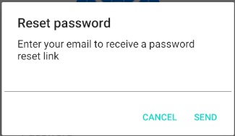

1. They should receive a password reset link in their email and they will be able to change their password.

# Registration

**PRE-REQUISITES:**

* The user must have used not used the app before with the same email address

1. The user must press on the ‘Not registered? Register here’



1. 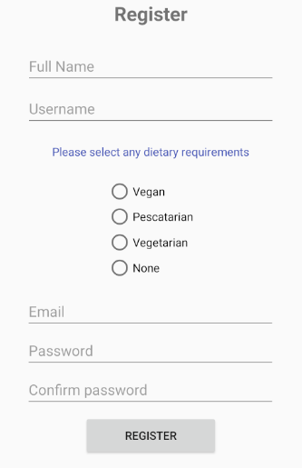The user must press on the following relevant text-fields and enter in their relevant details.
2. Next, select your relative dietary requirement from the list.



1. Finally, once all details have been entered and dietary requirements have been selected, press on the register button. This should store all the user details in the database and information will be stored for login next time.



# Virtual Fridge

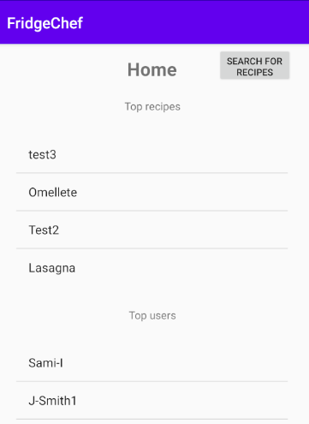

1. The user must select the ‘MYFRIDGE’ option from the navigation bar on the bottom of the screen to access the virtual fridge.

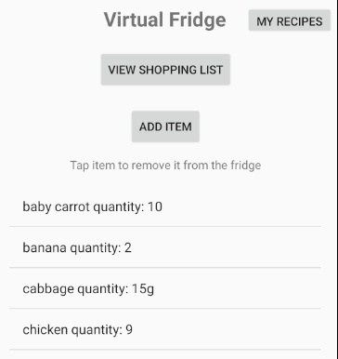

# Adding Items

1. Select the ‘ADD ITEM’ button from the Virtual Fridge page



1. Enter the relevant ingredient information here and select the relevant quantity measurement.

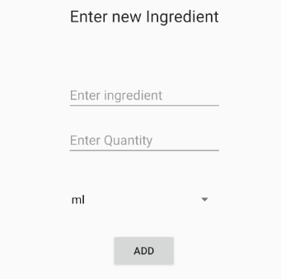

1. Finally, press the add button.



# View Shopping List

1. Press the ‘VIEW SHOPPING LIST’ button

# Adding Shopping List Items

1. Press the text-field with the ‘Enter Item’ button and enter the name of the item you want to add.



1. Next, press the ‘ADD’ button and the item will appear in the list below.

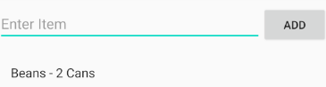

# Removing Shopping List Items

1. 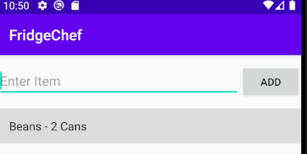Tap on the item you wish to remove.
2. The item will disappear, and a confirmation message will appear.



# Viewing Saved Recipes

1. Press on the ‘MY RECIPES’ button when on the virtual fridge page.



# Adding New Recipes

1. After going to my recipes page, you can press the ‘ADD NEW RECIPE’ button to go onto the new screen.



1. 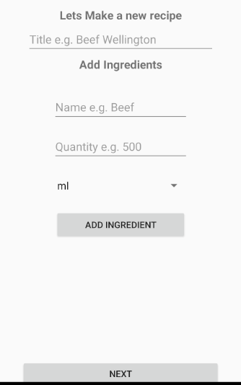Press on the relevant text-fields to name the recipe and then the add the required ingredients for the recipe and once the details are entered press the ‘ADD INGREDIENT BUTTON’

It will appear below these options as follows.



1. 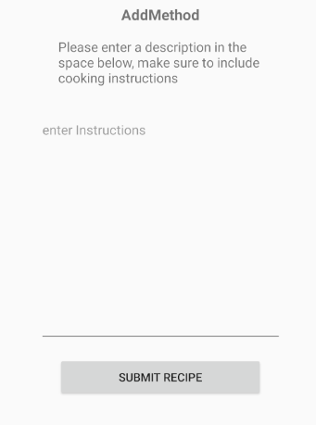Then, press the ‘next’ button to progress onto the next page. You should then be presented with the ‘Add Method’ page. Enter the relevant instructions in the ‘enter instructions’ and then press the ‘SUBMIT RECIPE’ button.
2. 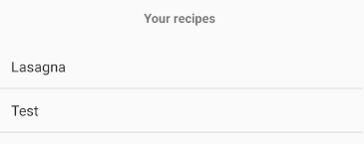It should then appear in the list.

# Viewing Profile Information

1. To view profile information, you can press the ‘PROFILE’ button on any page to view the profile information page.



1. 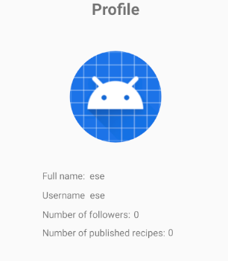All profile information will be shown on that page.

# Settings Page

1. To access the settings page the user must press the settings cog in the navigation bar.



1. 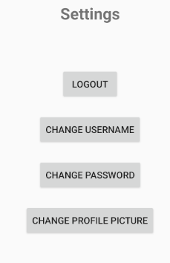From here, you can select a variety of other options.

# Change Username

1. On the settings page, you must click on the ‘CHANGE USERNAME’ button.
2. On the next page, select the text-field and type in your desired username. Once you are satisfied press the ‘OK’ button to confirm and the system will process the change.

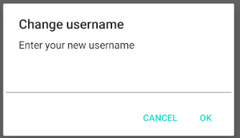

# Change Password

1. On the settings page, you must click on the ‘CHANGE PASSWORD’ button.
2. 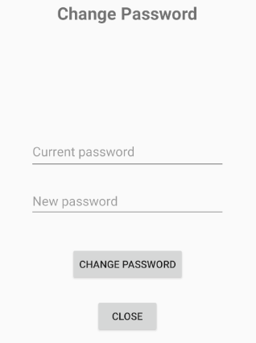Enter the relevant details into the 2 text-fields and then press the ‘CHANGE PASSWORD’ button to confirm the changes. The changes will then be saved in the system.

# Change Profile Picture

1. On the settings page, press the ‘CHANGE PROFILE PICTURE’ button.
2. You will then be directed to select a picture from storage. Select a picture and the picture will change.